Z-Wave

# Objective

Zwave (or Z wave or Z-wave) is a protocol for communication among devices used for home automation. It uses RF for signaling and control.

Zwave was developed by Zensys, Inc. a start-up company based in Denmark. Zwave was released in 2004. Based on the concepts of Zigbee, Zwave strives to build simpler and less expensive devices than Zigbee. In 2009 Sigma Designs of Milpitas, CA purchased Zensys/Zwave.

Dozens of manufacturers make Zwave compatible (to a lessor or greater extent) products, mostly in the lighting control space.

# The Basics

Zwave operates at 908.42 MHz in the US (868.42 MHz in Europe) using a mesh networking topology. A Zwave network can contain up to 232 nodes, although reports exist of trouble with networks containing over 30-40 nodes. Zwave operates using a number of profiles (think of them like languages), but the manufacturer claims they interoperate. Use care when selecting products as some products from certain manufacturers are not compatible with other manufacturers' products.

Zwave utilizes GFSK modulation and Manchester channel encoding.

A central, network controller, device is required to setup and manage a Zwave network. Each product in the home must be “included” to the Zwave network before it can be controlled via Zwave (and before it can assist in repeating/hoping within the mesh network).

Each Z-Wave network is identified by a Network ID and each device is further identified by a Node ID.

The Network ID (aka Home ID) is the common identification of all nodes belonging to one logical Z-Wave network. Network ID has a length of 4 bytes and is assigned to each device by the primary controller when the device is added into the network. Nodes with different Network ID’s cannot communicate with each other.

The Node ID is the address of the device / node existing within network. The Node ID has a length of 1 byte.

Z-Wave uses a source-routed mesh network topology and has one primary controllers. Secondary controllers can exist, but are optional. Devices can communicate to one another by using intermediate nodes to route around and circumvent household obstacles or radio dead spots that might occur though a message called “healing”. Delays will be observed during the healing process. A message from node A to node C can be successfully delivered even if the two nodes are not within range, providing that a third node B can communicate with nodes A and C. If the preferred route is unavailable, the message originator will attempt other routes until a path is found to the "C" node. Therefore, a Z-Wave network can span much farther than the radio range of a single unit; however, with several of these hops a slight delay may be introduced between the control command and the desired result.[5] In order for Z-Wave units to be able to route unsolicited messages, they cannot be in sleep mode. Therefore, battery-operated devices are not designed as repeater units. A Z-Wave network can consist of up to 232 devices with the option of bridging networks if more devices are required.

As a source routed static network, Z-Wave assumes that all devices in the network remain in their original detected position. Mobile devices, such as remote controls, are therefore excluded from routing.

Z-wave released later versions with added network discovery mechanisms so that 'explorer frames' could be used to heal broken routes caused by devices that have been moved or removed. A Pruning algorithm is used in explorer frame broadcasts and are therefore supposed to reach the target device, even without further topology knowledge by the transmitter. Explorer frames are used as a last option by the sending device when all other routing attempts have failed.

# Z Wave Protocol

The Z-Wave protocol is a low bandwidth half duplex protocol designed for reliable wireless communication in a low cost control network. The protocols main purpose is to communicate short control messages in a reliable manner from a control unit to one or more nodes in the network.

The protocol is not designed to transfer large amounts of data or to transfer any kind of streaming or timing critical data.

The protocol consist of 4 layers, the MAC layer that controls the RF media, the Transfer Layer that controls the transmitting and receiving of frames, the Routing Layer that controls the routing of frames in the network, and finally the application layer controls the payload in the transmitted and received frames.

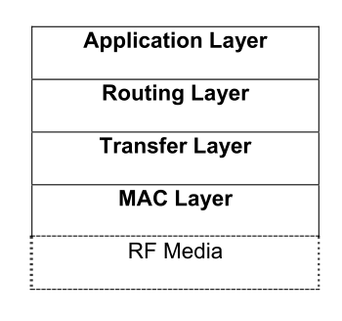

# Controller and Slave nodes

The Z-Wave protocol has 2 basic kinds of devices; controlling devices and slave nodes. Controlling devices are the nodes in a network that initiate control commands and sends out the commands to other nodes, and slave nodes are the nodes that reply on and execute the commands. Slave nodes can also forward commands to other nodes, which make it possible for the controller to communicate with nodes out of the direct radio wave reach.

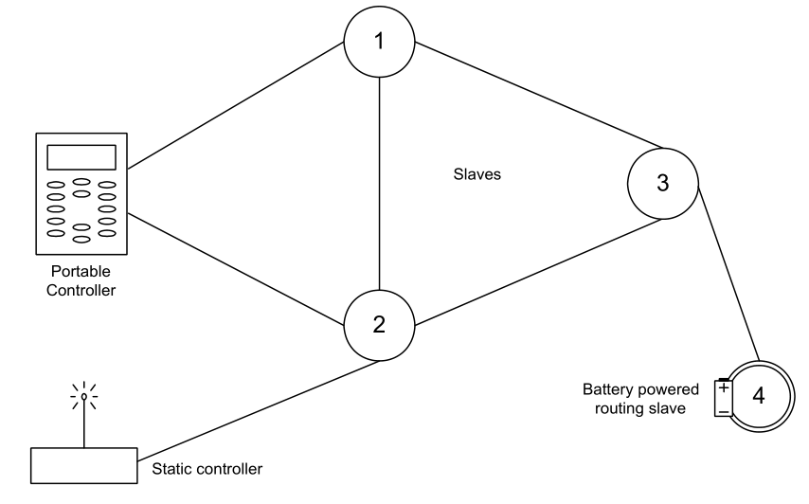

## Controllers

A controller is a Z-Wave device that has a full routing table and is therefore able to communicate with all nodes in the Z-Wave network. The functionality available in a controller depends on when it entered the Z-Wave network. In case the controller is used to create a new Z-Wave network it automatically become the primary controller. The primary controller is the “master” controller in the Z-Wave network and there can only be one in each network. Only primary controllers have the capability to include/exclude nodes in the network and therefore always have the latest network topology.

Controllers added to the network using the primary controller are called secondary controllers and don’t have the capability to include/exclude nodes in the network.

## Portable Controller

A portable controller is a controller, which is designed to change position in the Z-Wave network. The portable controller uses a number of mechanisms to estimate the current location and hereby calculating the fastest route through the network. An example of a portable controller could be a remote control.

## Static Controller

A static controller is a fixed controller that mustn’t change position in the network and has to be powered up all the time. This controller has the advantage that Routing slaves can report unsolicited status messages to it, and it also has the advantage of always knowing where it is located in the network. A static controller will typically be a secondary controller in a Z-Wave network.

An example of a static controller could be an Internet gateway that monitors a Z-Wave system.

## Static Update Controller

A Z-Wave network can optionally have a static controller with enabled Static Update Controller (SUC) functionality to distribute network topology updates. A SUC is a static controller that will receive notifications from the primary controller regarding all changes made to the network topology. In addition the SUC is capable of sending network topology updates to other controllers and routing slaves upon request. It is the application in a primary controller that requests a static controller to become a SUC. There can only be one SUC in a Z-Wave network.

## SUC ID Server

A Z-Wave network can optionally have a SUC with enabled node ID server functionality (SIS). The SIS enables other controllers to include/exclude nodes in the network on its behalf. The SIS is the primary controller in the network because it has the latest update of the network topology and capability to include/exclude nodes in the network. When including additional controllers to the network they become inclusion controllers because they have the capability to include/exclude nodes in the network on behalf of the SIS. The inclusion controllers network topology is dated from last time a node was included or it requested a network update from the SIS and therefore it can’t be classified as a primary controller.

## Installer Controller

An Installer controller is a portable controller that has additional functionality, which enables it to do more sophisticated network management and network quality testing than other controllers. An example of an installer controller could be an installation tool used by an installer to install a Z-Wave network at a customer site.

## Bridge Controller

A Z-Wave network can optionally have a bridge controller. A bridge controller is an extended static controller, which incorporates extra functionality that can be used to implement controllers, targeted for bridging between the Z-Wave network and other networks. The bridge controller device stores the information concerning the nodes in the Z-Wave network and in addition it can control up to 128 virtual slave nodes. A virtual slave node is a slave node that corresponds to a node, which resides on a different network type.

An example of a bridge controller could be a bridge between an UPnP network and a Z-Wave network to link broadband and narrowband devices together in a home entertainment application.

## Slaves

Slave nodes are nodes in a Z-Wave network that receives commands and performs an action based on the command. Slave nodes are unable to send information directly to other slaves or controllers unless they are requested to do so in a command. An example of a slave node could be a light dimmer.

## Routing Slave

Routing slaves has the same overall functionality as a slave. The major difference is that a routing slave can send unsolicited messages to other nodes in the network. They store a number of static routes for use when sending unsolicited messages to a limited number of nodes. An example of a routing slave node could be a thermostat or a Passive Infra Red (PIR) movement sensor.

## Enhanced Slave

Enhanced slaves have the same functionality as routing slaves and they are handled in the same way in the network. The difference between routing slaves and enhanced slaves is that enhanced slaves have a real time clock and an EEPROM for storing application data. An example of an enhanced slave node could be a weather station.

## Home ID and Node ID

The Z-Wave protocol uses a unique identifier called the Home ID to separate networks from each other. The Home ID is a 32 bit unique identifier that is pre programmed in all controller devices. All slave nodes in the network will initially have a home ID that is zero, and they will therefore need to have a home ID assigned to them by a controller in order to communicate with the network. Controllers in a network can exchange home ID’s so more than one controller can control slave nodes in a network.

Node ID’s are used to address individual nodes in a network, they are only unique within a network defined by a unique home ID. A node ID is an 8 bit value and like home ID’s they are assigned to slave nodes by a controller.

# Comparison with Zigbee, CoAp and 6LoWPAN

Put this in a tabular column. 4 columns , Z Wave, Zigbee, CoAp and 6LoWPAN.

# Applications of Z Wave

One para should be fine

# Summary

Just Summarise the whole thing. Again one para would be enough